**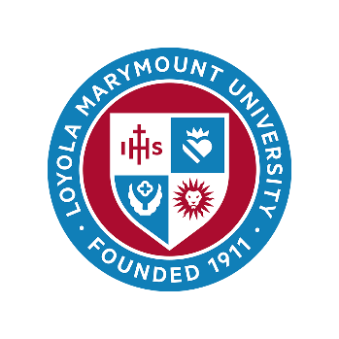

**Political Theologies of Constitutions, the Rule of Law, and the Common Good**

*23-24 April 2026*

*University of Cambridge*

The constitution functions not only as a legal framework but also as a symbolic and practical foundation for societal life. This brings to the fore the role of constitutional values and principles as shared reference points. Constitutions may be seen as manifestations of common values and principles, as articulations of normative frameworks, as institutional responses to collective challenges, expressions of a general will, or articulations of a covenant. However, polarisation, individualisation, and the fragmentation of social life are altering the role of constitutions in Western democracies. Today, constitutions have become caught up in the so-called ‘culture wars’.

This sixth Political Theologies conference interrogates social, political, legal, ethical, and theological foundations of constitutions and related to that, how constitutions are seen to embody and be directed toward the common good. What are the stories of constitutions that are told across the political spectrum? How have they been shaped by political memory (and forgetfulness), confessional commitments, and conceptions of the common good? How can stories of constitutions and the ways that they are understood to enable the common good adapt to the needs of pluralistic and polarised political communities? What can they say about the international community as well as domestic politics? How do different political theologies enable or disable democratic visions of the role of constitutions and the rule of law?

Papers and panel suggestions are invited from scholars in political theory, sociology, law, theology and religious studies, politics, history, anthropology, and philosophy, and may refer to any of the categories below. Applications from early- and mid-career scholars are especially encouraged.

1. Constitutions and the common good
2. ‘Common good constitutionalism’ – its champions and its critics
3. Founding narratives and myths of nationalism and statehood
4. The place of religion in constitutional frameworks, preambles, or constitutional texts (for example, establishment clauses)
5. Justificatory discourses for historical or future political settlements and constitutional arrangements
6. Political theologies of the rule of law and democratic resilience
7. Political theologies of pluralism and a democratic common life
8. The role of transnational religious movements/networks in anti-liberal and liberal political movements, ‘lawfare’ and culture wars as these relate to fundamental questions of political order
9. Constitutions and the role of religion in relation to the politics of exception, emergency politics, and the suspension of the rule of law

Please send a proposed paper title, short abstract (c. 200 words) and short biography to [mdcv2@cam.ac.uk](mailto:mdcv2@cam.ac.uk) or [pamela.slotte.russo@abo.fi](mailto:pamela.slotte.russo@abo.fi) by 6 December 2025. Decisions will be released by 17 December 2025. Short conference briefs of ca. 2,000 words are due by 1 April 2026.

**Associated events**

A college dinner will be hosted on the evening of Thursday 23 April 2026. The dinner will be included as an optional item at registration and is open to speakers and attendees of the conference.

**Funding and embedding**

A limited number of travel bursaries may be offered to speakers based on need. Cost of travel will only be considered in exceptional circumstances and applicants must make a strong case that no other funding is available to them. All requests for bursaries must be submitted by 6 December 2025.

This conference is generously funded by the Landecker Foundation, DAAD-Cambridge Research Hub for German Studies, the Chair of Religion and Law at Åbo Akademi University, the Huffington Ecumenical Institute of Loyola Marymount University, the Inez and Julius Polin Institute for Theological Research and the McDonald Centre for Theology, Ethics, and Public Life at the University of Oxford.

The Political Theologies conference series grew out of the Protestant Political Thought project, hosted at the Blavatnik School of Government, Oxford and continues as part of the Landecker Lectureship ‘Imagining Sacred Lands’ at the University of Cambridge. This project has featured a series of workshops and conferences, many of which have led to collaborative publications, including in The Journal of the Bible and its Reception (2021), Religion, State, Society (2022), as well as the edited collection *The Many Faces of Christianism: The ‘Russian World’ in Europe* (2025). For more information, email Marietta van der Tol at mdcv2@cam.ac.uk.